SWT41051: Practical for Advanced Software Engineering
CA01
Reg:SEU/IS/20/ICT/084 Date:2026/05/11
Question01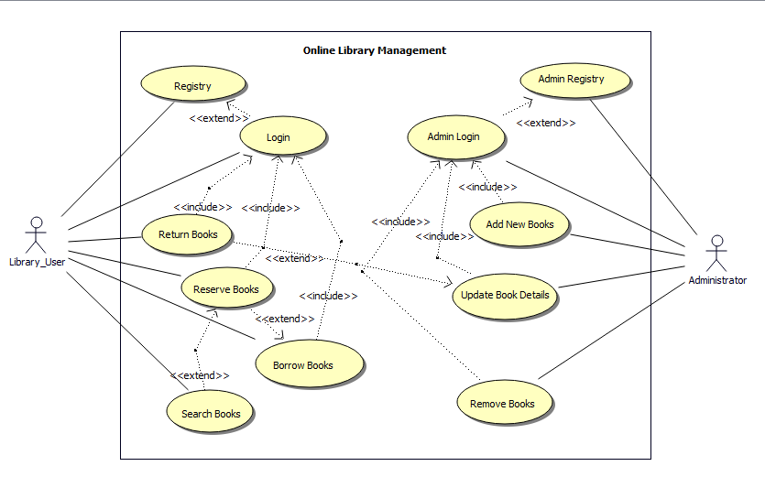

Question02
